**Food Consumption Score Nutrition**

**Design**

WFP sought to test the feasibility of collecting the Food Consumption Score-Nutrition (FCS-N) indicator through SMS (text messages). While the standard FCS-N has a seven-day recall period, WFP tested if respondents are able to better recall what they consumed when asked about what they ate in the last 24 hours every day for seven consecutive days. The survey was administered to a panel of respondents. The sample groups compared across this study include

**Group A**: SMS respondents who replied to the FCS-N for seven consecutive days with a 24-hour recall period (Group A=24h) and respondents who replied to the FCS-N on day eight using a seven-day recall period (GroupA=7days).

**Group B or control group:** SMS respondents who replied to the FCS-N on day eight using a seven-day recall period (Group B=7days)

***Graph 1: Design of the mode experiment***



Asking respondents in Group A the seven-day recall on Day eight allowed us to compare the responses from the previous seven days to see if respondents answer vary greatly depending on the recall period. In addition, compared the SMS FCS-N data collected every day for seven consecutive days (24-hour recall) with the face-to-face survey data (FCS-N asked with seven-day recall) to assess potential mode biases (i.e., if people respond differently on the phone versus face-to-face). For this purpose, WFP conducted the SMS surveys at the same time of the annual face-to-face Mozambique Secretariado Técnico de Segurança Alimentar e Nutricional (SETSAN) assessment (August 2017), since the SETSAN collects FCS-N data. This test was conducted in two rural districts – Tete and Zambezia – and carried out for one round. The language of the interviews for the SMS and F2F surveys was Portuguese.

As per standard survey procedures, respondents’ consent was obtained prior to the interviews, and an airtime credit incentive of $0.10 was provided to the respondents following completion of the survey. mVAM research shows that providing a pecuniary incentive to respondents who successfully complete the questionnaire is often required to ensure a high response rate. For this reason, all respondents received this incentive for their participation.

This analytical paper is structured as follows:

*In Section 1*, we report on the total number of households who were reached in the SMS surveys, illustrating some production statistics on the number of respondents who were ineligible, completed the survey, or dropped off.

*In Section 2*, we check if respondents in Group A change their answers when the same demographic questions are asked on two different days. Then, for the same group of respondents, we compare the FCS-N indicator to see if the score changes when the recall period is changed from 24 hours to seven days.

*In Section 3*, we compare the FCS-N indicator among SMS respondents who replied to the FCS-N for seven consecutive days using a 24-hour recall period (Group-A 24H) with the results yielded from SMS respondents who replied to the FCS-N on Day eight, using the seven-dayrecall period (Group-B seven days).

*Section 4*: we compare the FCS-N answers provided by SMS respondents who replied to the FCS-N for seven consecutive days with a 24-hour recall period (Group-A 24H) against the results yielded from the F2F respondents (F2F seven days).

In each section, before comparing the FCS-N answers, we check if the groups (Group-A 24H, Group-B seven days and F2F seven days) are similar in terms of demographics.

**SECTION 1**

**Sample and attrition of the SMS surveys**

A total of 20,500 respondents (19,400 for Group A and 933 for Group B) were contacted to be part of the pool of respondents for the SMS surveys. Among those:

* Around 50% of respondents in both groups were ineligible to take part to the SMS survey because their age was below 18 or because they lived in an urban area or in a district that was not part of the survey.
* **Group A:** 43% of respondents completed the survey at least once, and 12% of those respondents completed the SMS survey for eight \ consecutive days.

**Group B:** 22% of respondents completed the SMS survey on day eight.

Around 11% of respondents in both groups dropped out, meaning that they only partially completed the survey. The questionnaire asked respondents in Group A a series of 27 questions while respondents in Group B were asked 24 questions. The difference in the number of questions derives from the fact that the Group B respondents were not asked the three open-ended questions on what they ate respondents for breakfast, lunch, and dinner the day before. Despite the slightly different question lengths, across both sample groups, approximately 75% of respondents who accepted to take part in the questionnaire dropped out after the ninth question (*Table 1).*

***Table 1: Percentage of households who dropped out of the survey***



**SECTION 2**

**Group-A 24H versus Group-A seven days**

Focusing on the sample of 133 respondents in Group-A 24H and Group-A, who replied to the SMS surveys for eight consecutive days (detailing what they ate during the 24-hour period before the interview from day one to day seven and what they ate in the past seven days on Day 8) – we are going to check if same respondents answer consistently when:

1. the demographic questions were asked on two different days
2. the FCS-N was asked with a different recall period (24-hour versus seven-day).

**Consistency in the respondents ‘demographic answers for respondents in Group A across both recall methods**

Questions on gender of the respondent, district, and toilet and roof types were asked only at the beginning (day 1) and at the end (day 8) of the SMS surveys for respondents in Group A. We conducted a deeper analysis on the demographic section of the questionnaire to determine if the same respondents changed their answers when the same demographic questions were asked on two different days.

We observed that:

* Approximately 30% of the respondents changed their answers from day one to day eight for toilet type and roof type
* 15% replied with a different age; and
* Approximately seven percent changed gender.

Changes in the toilet type and roof type answers could be explained by the fact that the options given for those two questions were not clear and/or were not well visible on basic phone screens. For this to be the case, we are assuming that most of the respondents replied to the SMS surveys using basic phones as opposed to smart phones, as the SMS survey was implemented in rural areas. For this reason, we hypothesize that respondents may have replied with one of the options visible on their screen instead of selecting the most-appropriate response. No evidence illustrates that respondents gave a better or worse answer in day eight compared to day one for these two questions.

Changes in the age and the sex of the respondents could be due to the fact that different respondents within the household (i.e., the head of household one day and another person the second time) replied to the SMS survey on day one and day eight.

Based on the above results, it is highly recommended that the demographic questions be asked each time respondents take part in an SMS survey if the same numbers will be used for multiple rounds. This recommendation is especially important when conducting SMS-based surveys, because we cannot otherwise ensure that the same respondent is participating in the survey each time. .

For the purpose of the analysis, when the answers to the demographic questions changed from day one to day eight, we kept the answers provided by respondents during the first day.

**Demographic information of respondents in Group-A**

As illustrated in *Graph 2*, 94% of respondents in Group-A are from Tete District and 6% are from Zambezia District. That said, even though this survey targeted solely rural areas of Mozambique, the survey reached predominantly better-off respondents. We can determine the respondents’ economic status by analysing the results provided for the “roof type” and “toilet type” wealth proxy indicator questions. The most common types of roofs reported by respondents were “*metal*”, “*asbestos*” and “*concrete.*” For toilets, common responses included “*VIP,*” “*improved,*” and “*flush.*”

***Graph 2: Proportion of respondents by district, toilet type and roof type***

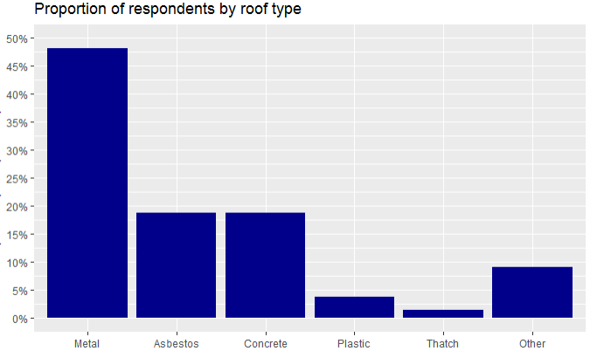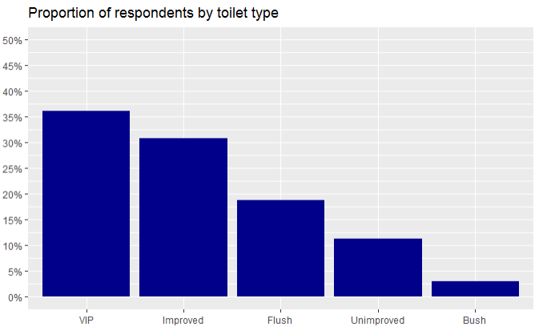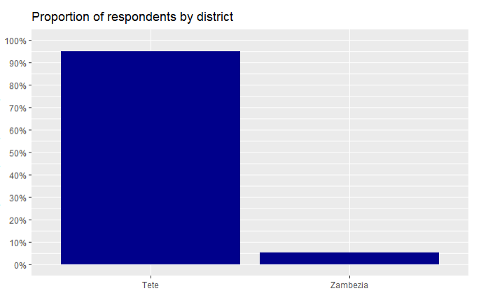

**Food Consumption Score Nutrition (FCS-N) analysis**

As the purpose of the FCS-N analysis is to assess nutrient adequacy by looking at the frequencies of consumption of food groups’ rich in the nutrients, the following three food groups were created:

1. **Vitamin A-rich foods** including dairy, organ meat, eggs, orange and green vegetables, and orange fruits;
2. **Protein-rich Foods** including pulses, dairy, flesh meat, organ meat, fish, and eggs; and
3. **Hem iron-rich foods** including flesh meat, organ meat, and fish.

The aim of this analysis is to see if we are able to arrive at the same estimates for the FCS-N when the FCS-N module is asked using a different recall period – 24 hour vs seven day.

When we compared the answers from the same group of respondents (Group-A 24H versus Group-A seven day) across the two districts, we see that there are no significant differences for the protein=rich food group, meaning that the results yielded when using the 24-hour recall period provided similar estimates to those received using the seven-day recall period . (*Table 2*). However, respondents tended to report consuming more Vitamin A and Hem Iron Foods when the recall period was 24 hours. It appears that, with a bigger recall period, the likelihood that respondents underestimate the consumption of specific food items is higher.

***Table 2: Percentage of households who are consuming Vitamin A, Protein and Hem iron rich food groups by district***



The FCS-N analysis for Zambezia District was conducted even if the sample size is small because we are interested in looking at the possible changes in the indicator when using a different recall period.

**SECTION 3**

**Group-A 24H versus Group-B sevenDays**

**Demographic information**

Before starting with the FCS-N analysis, we evaluated the demographic similarities and differences across the two groups. As *Table 3* shows, the two groups differ. Respondents in Group-B seem to be worse-off than respondents in Group-A, as a larger proportion of respondents in Group-B replied that they use the “*bush*” as toilet facility and have either a “*plastic*” or “*thatch.*” This difference could be explained from the fact that more respondents in Group-B are from Zambezia Distric, which is classified aspoorer than Tete District.

***Table 3: Demographic characteristics for Group-A and Group-B SMS surveys***

|  |  |  |  |  |
| --- | --- | --- | --- | --- |
|  | | **Group A 24Hr recall** | **Group B sevenDay recall** | **p-value** |
| **Age of the respondents** | **Age in years** | 24 | 24 | 0.6877 |
| **Gender of the respondent** | **Male** | 71.15% | 80.29% | 0.0113 |
| **District** | **Tete** | 69.03% | 55.77% | 0.0006 |
| **Zambezia** | 30.96% | 44.23% |
| **Toilet Type** | **VIP** | 33.27% | 31.25% | 0.5998 |
| **Improved** | 27.11% | 30.77% | 0.3221 |
| **Flush** | 25.00% | 15.38% | 0.0048 |
| **Unimproved** | 10.96% | 13.94% | 0.2603 |
| **Bush** | 3.65% | 8.65% | 0.0055 |
| **Roof Type** | **Metal** | 44.04% | 37.5% | 0.1066 |
| **Asbestos** | 21.15% | 18.27% | 0.3823 |
| **Concrete** | 17.50% | 11.54% | 0.0463 |
| **Plastic** | 5.38% | 12.98% | 0.0004 |
| **Thatch** | 1.73% | 3.85% | 0.0877 |
| **Other** | 10.19% | 15.87% | 0.0321 |

**Food Consumption Score Nutrition analysis**

Even if respondents in Group-B seven day appear to be more vulnerable than respondents in Group-A 24H, we still compared the percentage of households across both groups by consumption frequency of nutrient=rich food groups by district, toilet type, and roof type. The purpose of this comparison was to see if we derive similar estimates for the FCS-N when it is asked using different recall periods (i.e., 24 hour versus seven days).

Overall, results show that there are not many differences among Group-A 24H and Group-B seven day in terms of the percentage of households who reported consuming Vitamin A-rich foods either 0 days, 1-6 days or seven. The same holds true for the consumption of , protein, hem and iron rich food groups. However, differences were observed for respondents having “*asbestos*” or “*plastic*” roofs and “*VIP*”, “*improved*” or “*bush*” latrines (*Graph 3*). As illustrated in *Graph 3,* higher proportion of respondents in Group-A 24H reported not having consumed protein and hem iron rich food groups during the recall period compared to respondents in Group-B who reported consuming said foods more often (from 1 to 6 days) during the recall period. The difference could be explained from the fact that, with a longer recall period (seven days), respondents tend to have more difficulties recalling the exact number of days they consumed various commodities during the previous week. Thus, they may just respond with a value between one and six, indicating that they consumed each foodstuff “sometimes.”

***Graph 3: Mosaic plot on the percentage of household who reported consuming Vitamin A, protein and hem iron rich foods for 0 days, 1-6 days and seven days, disaggregated by toilet type and roof type***

**Toilet Type**

***Vitamin A-rich Foods*** 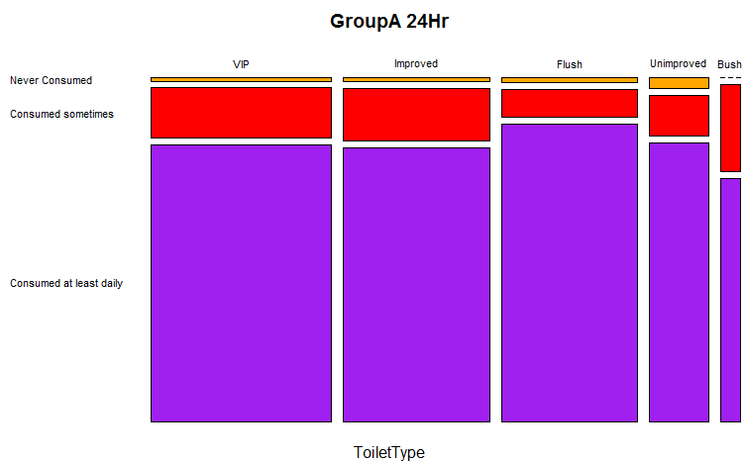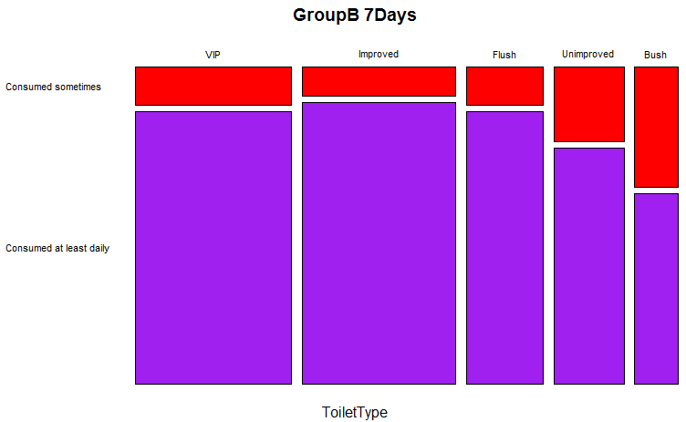

***Protein-rich Foods***

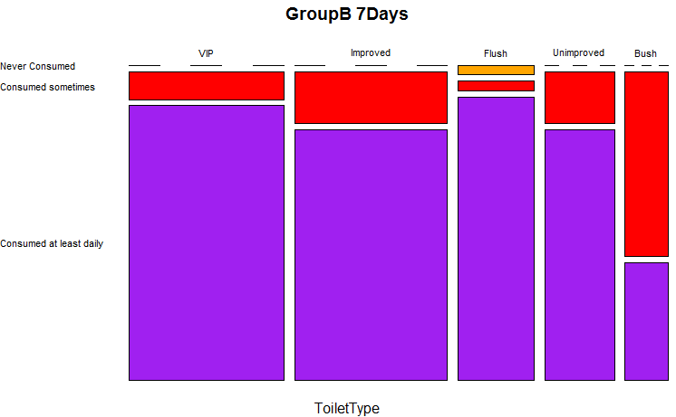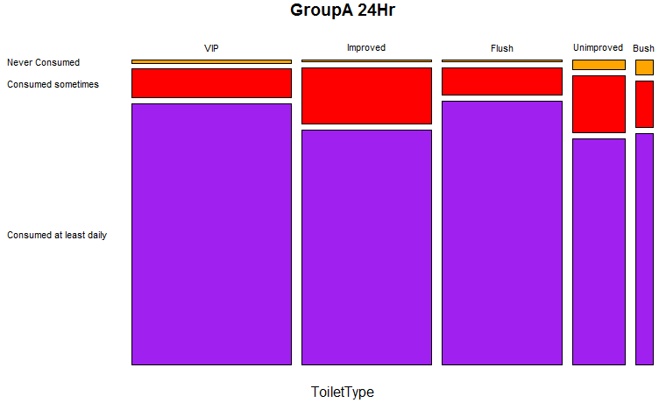

*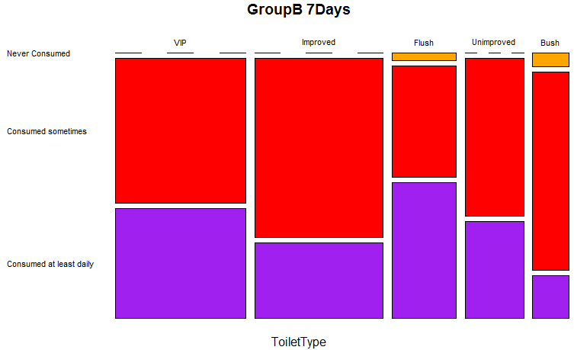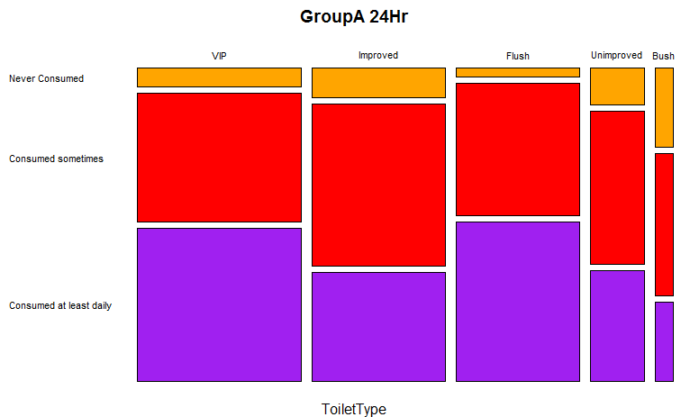****Hem iron-rich Foods***

**Roof Type**

***Vitamin A-rich Foods***

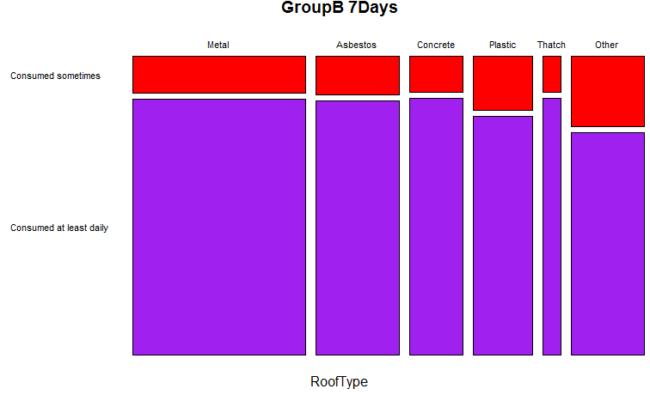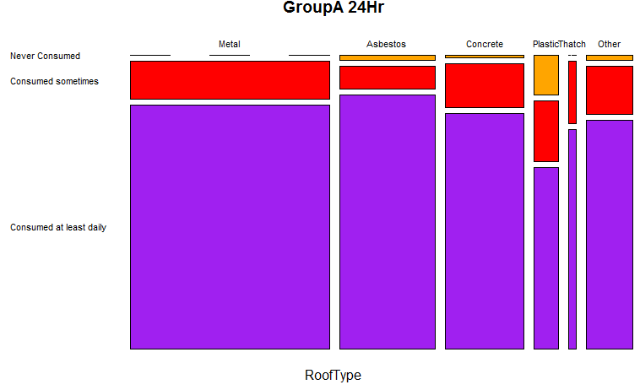

*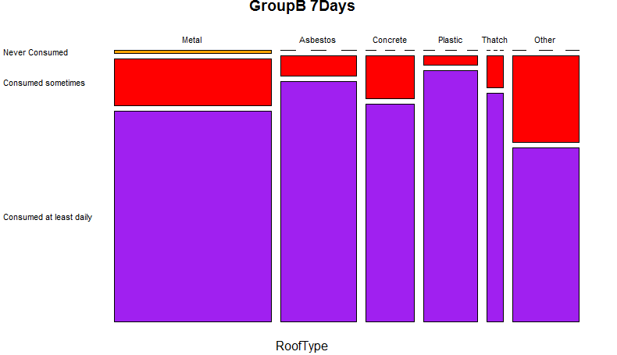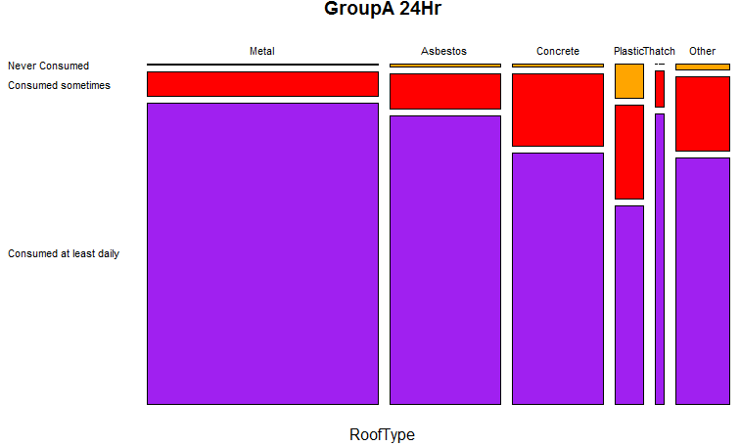****Protein-rich Foods***

*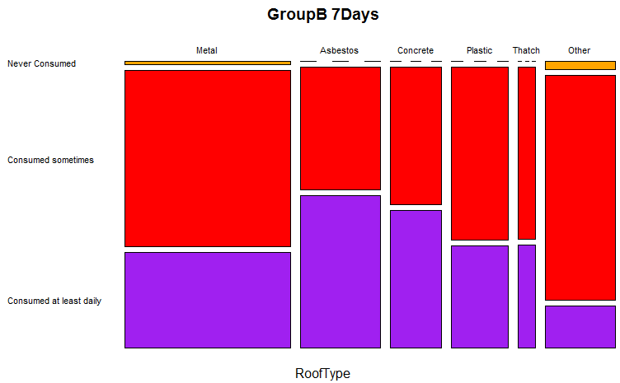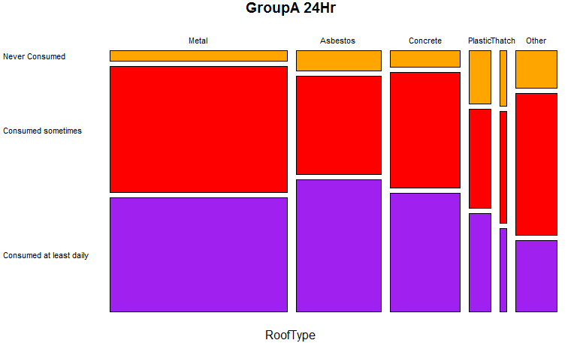****Hem iron-rich Foods***

When looking at the distribution of the consumption of individual food items (*Graph 4*), it appears that the seven-day recall period is resulting in an underestimation of the respondents who did not consume any vitamin A, protein, or hem iron-rich food groups druing the recall period. Among respondents in Group-B seven days, *one day* was the most frequently reported response for consumption of these foods, followed by two and three days for all food items. Differently, for respondents in Group-A 24H, 0 days followed by one and two were the most frequent responses mentioned. The graph below further illustrates that three and four days of consumption are the least-mentioned days of consumption reported by respondents in Group-A 24H.

However, even if the distributions are different, fruits, organ meat, and dairy are the least-consumed food items reported by both groups, while pulses is the most consumed food item.

***Graph 4: Distribution of the single food items for Group-A 24H and Group-B seven day***

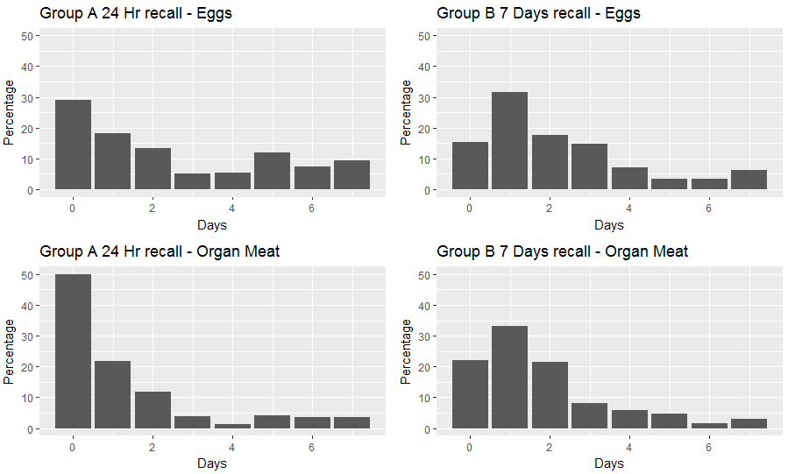

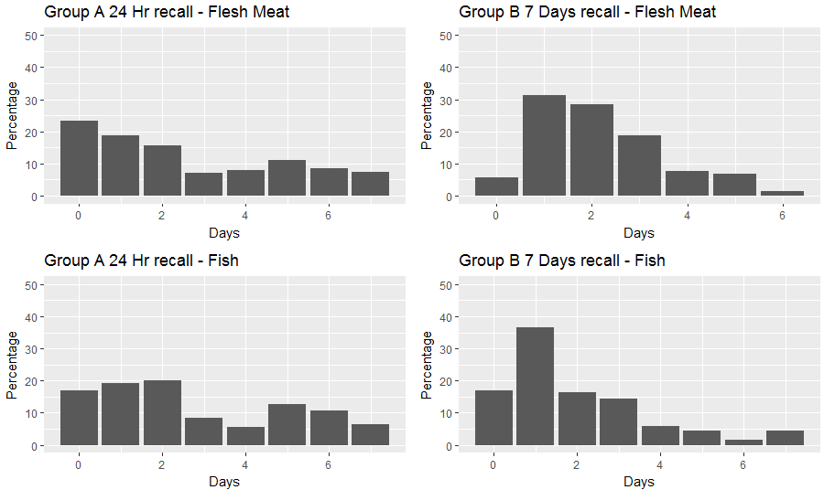

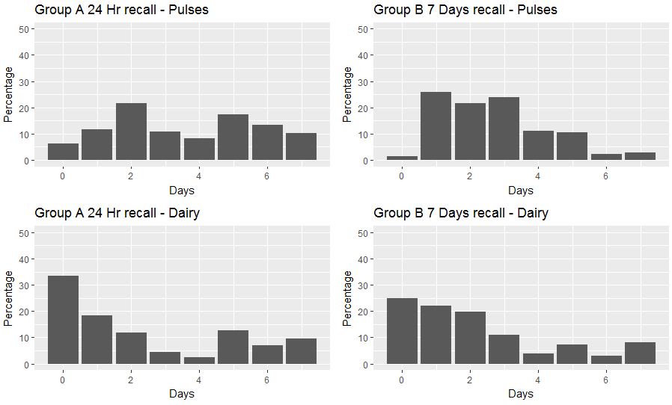

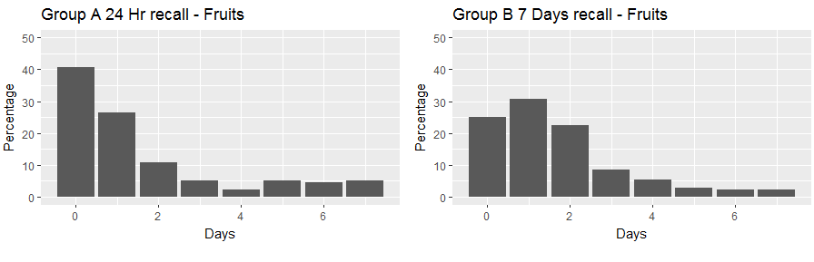

**SECTION 4**

**Group-A 24H versus F2F seven days**

**Demographic information**

As *Table 4* shows, the F2F and SMS samples are different in terms of the gender of respondents and toilet type. Particularly, the SMS survey seems to reach better-off respondents compared to those reached as part of the F2F survey. To assess the wealth of respondent households, the type of toilet used by each household is used as a proxy indicator to determine the household’s socio-economic status. To be able to compare the share of households owning the same type of toilet among the two groups, the different types of toilets were aggregated and categorised as follows:

**F2F**

|  |
| --- |
| Original category New Category |
| Improved traditional latrine VIP |
| Western toilet with flush Western |
| Western toilet without flush Western |
| Improved latrine Improved |
| Traditional unimproved latrine Unimproved |

**SMS**

|  |
| --- |
| Original category New Category |
| Traditional Improved latrine VIP |
| Improved latrine Improved |
| Western style Western |
| Unimproved latrine Unimproved |
| In the wood Unimproved |

More than 60% of the SMS respondents have a “*VIP*” or “*improved*” latrine, while more than 50% of F2F respondents reported having an “*improved*” latrine.

|  |  |  |  |  |
| --- | --- | --- | --- | --- |
|  | | **Group A 24Hr recall** | **F2F seven Day recall** | **p-value** |
| **Gender of the respondent** | **Male** | 71.15% | 30.43% | 2.2e-16 |
| **District** | **Tete** | 69.03% | 47.96% | 9.387e-15 |
| **Zambezia** | 30.96% | 52.04% |
| **Toilet Type** | **VIP** | 33.27% | 10.75% | 2.2e-16 |
| **Improved** | 27.11% | 5.81% | 2.2e-16 |
| **Western** | 25.00% | 0.98% | 2.2e-16 |
| **Unimproved** | 14.62% | 82.47% | 2.2e-16 |

***Table 4:*** Population's proportions in Group-A and F2F surveys.

**Food Consumption Score Nutrition analysis**

Significant differences were observed among the Group-A 24H and F2F seven days in terms of the percentage of households who reported consuming vitamin A, protein, and hem iron rich foods either 0 days, 1-6 days or seven days. Since the F2F sample seems to reach poorer respondents than the SMS sample, a higher percentage of F2F respondents reported having not consumed foods from the vitamin A, protein and hem iron-rich food groups compared to the Group-A 24H. At the same time, a lower percentage of F2F respondents reported consuming those three food groups every day compared to the SMS respondents.

***Table 5: Percentage of households who are consuming Vitamin A, Protein and Hem iron-rich food groups by district, roof and toilet types***



**Conclusions**

The three groups analysed (Group-A 24H, Group-B seven days and F2F seven days) differ in terms of demographics. Respondents in Group-A 24H seem to be better-off than respondents in Group-B seven days and F2F seven days. The differences observed in the respondents’ characteristics could explain the consumption frequency of nutrient-rich food groups for households, disaggregated by toilet and roof type differ among the groups.

The analysis conducted also shows that, with a shorter recall period (24 hour), respondents were able to recall better if specific food groups were not consumed at all (0 days of consumption) or consumed on a daily base (seven days).